Image | 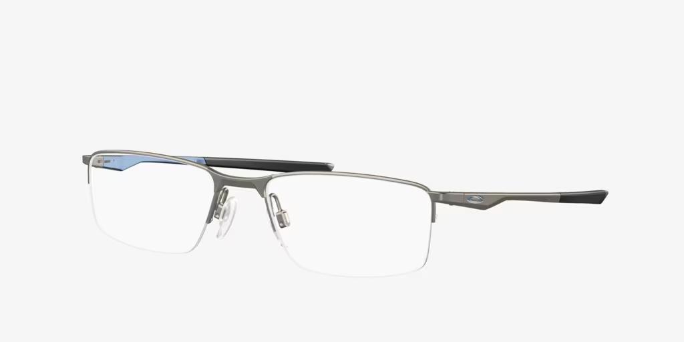
Brand | MICHEAL KORS
Model Name | OX3218 SOCKET
Price | RS 2500
PRODUCT DETAILS

